# Project Design Phase-II

**Data Flow Diagram & User Stories**

|  |  |
| --- | --- |
| **Team ID** | PNT2022TMID10050 |
| **Project Name** | Personal Assistance for senior citizens who are self-reliant |
| **Maximum Marks** | 4 Marks |

Data Flow Diagram:

1. The user should register on MedCare(web application) by using their mail ID, password and get verified.
2. User can set medicine name and time by MedCare (mobile application).
3. The data given as input by the user on mobile application is stored in IBM Cloudant database.
4. The IOT device is made to remind the medicine name at correct time by voice commands through IBM Watson platform.
5. The SMS is sent to the user to notify the intake of medicine which is initiated by mobile application.

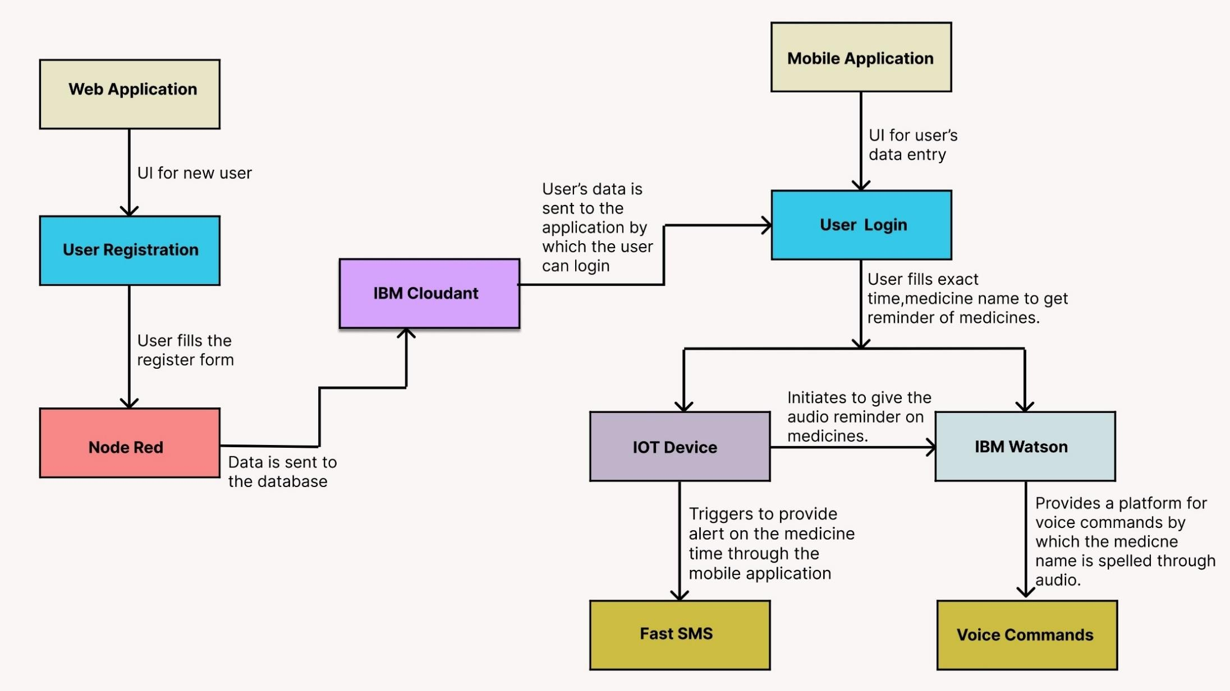

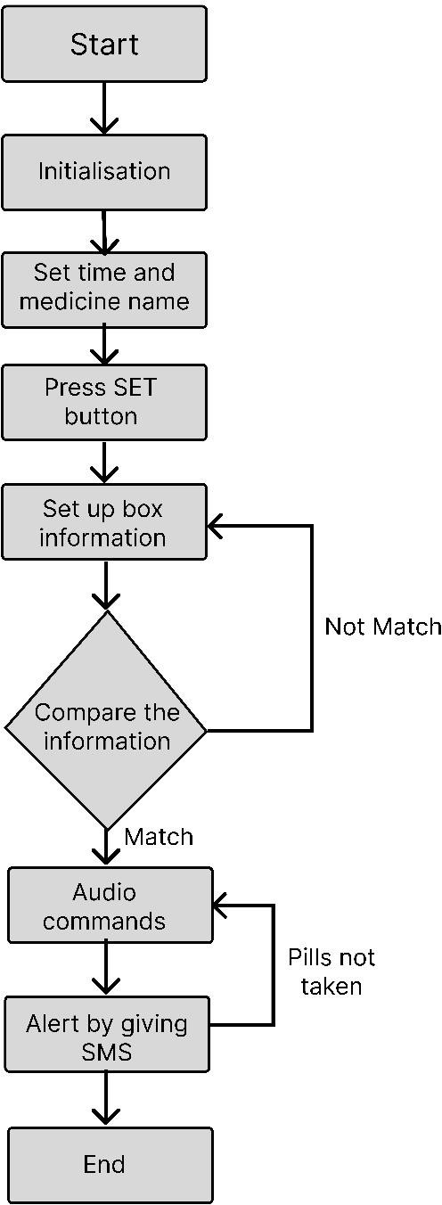

# User Stories:

|  |  |  |  |  |  |  |
| --- | --- | --- | --- | --- | --- | --- |
| **User Type** | **Functional Requirement (Epic)** | **User Story Number** | **User Story / Task** | **Acceptance criteria** | **Priority** | **Release** |
| Customer (Senior citizen) | Caretaker | USN-1 | As a user, I want to take medicines on time so that I can my health. | I want to take medicine on time. | High | Sprint-1 |
| Customer (Mentally idled patient) | Janitor | USN-2 | As a user, my patient should maintain good health by consuming medicines on time. | My patient needs to take medicines at proper time. | High | Sprint-2 |
| Customer (Disabled person) | Smart medicine box | USN-3 | As a user, I need to take my medicines at correct time through nearby person via SMS. | I need to take medicines at accurate time by notification. | Medium | Sprint-4 |
| Customer (Coma patient) | Virtual medikit | USN-4 | As a user, my patient medication time and name should be loaded in database. | My patient’s medicine name and time should be in database list. | High | Sprint-2 |
| Customer (Alzheimer patient) | Digital medicare | USN-5 | As a user, I want to take medicines on time by voice commands. | I want to take medicines on time by voice assist. . | Medium | Sprint-3 |